The efficacy of two different insecticides on

western flower thrips pupae

*Congxing Zhu*

*December 8, 2017*

**Abstract**

Western flower thrips (WFT), *Frankliniella occidentalis* (Pergande), is an economically important pest of a wide range of crops grown throughout the world. This particular species of thrips is difficult to control because they hide deep in the folds of plant buds, or in the soil where foliar insecticide sprays can’t reach them. Even when insecticides come in contact with WFT, continued applications can foster the development of resistant WFT populations.

New pesticides are required to maintain effective resistance management strategies for control of WFT. We tested the efficacy of KleenGrow™, and STRIP-IT PRO™ WFT pupae, two neonicotinoids that represent a newer class of insecticides for the control of thrips. The result shows there are some efficacy for both of the two insecticides, but there are not too many differences between them.

**Introduction**

Thrips belong to the insect order Thysanoptera. About 5000 species are known and they occur all over the world (1) (Richards & Davies 1978). The western flower thrips, *Frankliniella occidentalis* belongs to the family Thripidae, the family in which most of the economically important thrips species are found (2) (Brødsgaard 1989). *Frankliniella occidentalis* is a small insect, adults are about 1 mm long and the females are usually larger than the males. Adults have two pairs of narrow wings that are fringed with long, fine hairs. The wings are held parallel along the back when at rest. The color of the females can vary from pale yellow to dark-brown or black; males are always yellowish (3) (Tommasini & Maini 1995). Adult female *F. occidentalis* lay eggs singly into the parenchymal tissues of leaves, flowers, or fruits. The eggs hatch into small, white, first instar larvae which immediately begin to feed. The insects pass through two larval stages. Toward the end of the second larval stage, the insects stop feeding and move down the plant into the soil or leaf litter to pupae. The thrips pass through two ‘pupal’ stages (propupal and pupal), during which no feeding and little movement occur. The pupal stages can be recognized, among other things, by the presence of wing buds (3) (Tommasini & Maini 1995). At moderate temperatures, 20–25 °C, it usually takes *F. occidentalis* about 2–3 weeks to develop from egg to adult. However, the developmental time is strongly influenced by the temperature. At 15 °C the development from egg to adult may take more than a month, but at 30 °C and above it may take less than 10 days (3) (Tommasini & Maini 1995). The fecundity of *F. occidentalis* may also depend on the temperature but it is probably more affected by the host plant and especially availability of pollen as a high quality food source (2) (Brødsgaard 1989). Studies on other species of *Frankliniella* have shown that reproduction is facultative parthenogenetic (2) (Brødsgaard 1989). Female thrips can lay fertilized eggs that develop into females and unfertilized eggs that develop into males, i.e. arrhenotoky. The female thrips are diploid and the male thrips are haploid (4) (5) (Heming 1995; Moritz 1997).

Western flower thrips has become one of the major insect pests of vegetable, fruit and ornamental crops (6) (Lacasa & Llorens 1996). It is a serious insect pest, feeding on a wide range of crops throughout the world and causing substantial economic crop losses (7) (Lewis 1998). It can reduce crop yields by direct feeding damage and by transmitting the tospoviruses impatiens necrotic spot virus (INSV) and tomato spotted wilt virus (TSWV). *Frankliniella occidentalis* can be difficult to control. Use of insecticides has been the primary strategy for controlling WFT, especially in virus-sensitive crops, where a great number of specific treatments are applied against it. However, the range of insecticides and formulations that are effective against WFT is limited. Insecticide resistance has been documented in a number of chemical classes, including the organochlorines, organophosphates, carbamates, pyrethroids and spinosyns (8) (Immaraju & Paine 1992).

Owing to the high cost of insecticides, including research, registration and production, it is important to use the best insecticides with high efficacy to control it. The objective of the following perspective is to discuss the efficacy of two different insecticides on the pupal stage of western flower thrips.

**Materials and Methods**

A. Insect colony

A laboratory colony of WFT was maintained on green beans (Phaseolus vulgaris L.), purchased from a local supermarket (Dillons; Manhattan, KS), in Glad® (The Glad Products Company; Oakland, CA) plastic containers [20.4 x 14.4 x 9.4 cm (length x width x height)] with No-Thrips insect mesh (150 x 150 microns: Greentek; Edgerton, WI) under the following conditions: 24 ± 3ºC, 50% to 60% relative humidity, and constant light. In order to provide food for the larvae, and food and oviposition sites for adults, green beans were changed every 2 to 3 days.

B. Experiment

The study involved an experiment that was set-up as a completely randomized design. Two chemicals were evaluated: 1) dodecyl dimethyl ammonium chloride (KleenGrow™: Pace 49, Inc.; Burnbury, BC, Canada) and 2) acid-based phosphate-free cleaner (STRIP-IT PRO™: Pace 49, Inc.; Burnbury, BC, Canada). Four concentrations of KleenGrow™ were tested: 1.0 fl oz/1 gallon, 0.5 fl oz/1 gallon, 0.13 fl oz/1 gallon, and 0.06 fl oz/1 gallon; and two concentrations of STRIP-IT PRO™ were tested: 8.0 fl oz/1 gallon and 5.0 fl oz/1 gallon. There was also a water control and blank (untreated) check. There were total of 8 treatments with 5 replications per treatment. The treatments were all prepared in 400 mL of water based on the rates provided by Judy McWhorter (Pace 49, Inc., National Sales Manager). The treatments and rates used are presented below (Table 1):

|  |  |
| --- | --- |
| Treatments | Concentrations |
| Blank | / |
| Water | / |
| KleenGrow™ | 1.0 fl oz/1 gallon (3.0 mL/400 mL) |
| KleenGrow™ | 0.5 fl oz/1 gallon (1.5 mL/400 mL) |
| KleenGrow™ | 0.13 fl oz/1 gallon (0.40 mL/400 mL) |
| KleenGrow™ | 0.06 fl oz/1 gallon (0.18 mL/400 mL) |
| STRIP-IT PRO™ | 8.0 fl oz/1 gallon (25 mL/400 mL) |
| STRIP-IT PRO™ | 5.0 fl oz/1 gallon (15.6 mL/400 mL) |

Table 1. Different treatments associated with different concentrations.

Growing medium preparation for the experiment was as follows: a 6.0-L plastic container (Rubbermaid Home Products; Wooster, OH) was filled with Sunshine LC1 RSi Professional Growing Mix growing medium (SunGro Horticulture Canada Ltd.; Seba Beach, Alberta, Canada) consisting of 70 to 80% Canadian sphagnum peat moss, perlite, and dolomitic limestone. The growing medium was moistened with approximately 200 mL of water. The plastic container with growing medium was then heated for 25 minutes in a microwave set at full-power (1,200W output). After the growing medium was allowed to cool, 1,800 mL of water was applied to the growing medium. About 400 mL of growing medium was placed into a 473mL deli container. The deli container was tapped five times to reduce the amount of air-space within the growing medium.

Twenty WFT pupae, obtained from the laboratory colony, were randomly positioned on the growing medium surface. Pupae are generally located at a depth of 1 to 5 mm in the growing medium. The pupae can be distributed through the growing medium via cracks and crevices present on the growing medium surface, so no additional growing medium was needed to cover the pupae. Then 75 mL of each treatment solution was uniformly applied as a drench to the growing medium surface. A lid was modified with No-Thrips insect mesh for ventilation, which prevented emerging WFT adults from escaping. A half-section of a yellow sticky card [7.7 x 10.4 cm (length x width): Pestrap Phytotronics, Inc.; Earth City, MO] was affixed to the center of the lid in order to capture emerging WFT adults. Each 473mL deli container was placed into a larger petri dish (14.0 cm diameter) to collect any leachate from the bottom of the deli containers. The deli containers were exposed to laboratory conditions [22 ± 3°C and 18:6 (L:D) hour photoperiod]. The number of WFT adults captured on the yellow sticky cards was counted 15 days after the experiment was initiated.

**Results and Discussion**

The number of WFT adults captured on the yellow sticky cards in each treatment is presented in the boxplot (Figure 1). And we can see, The KleenGrow™ concentrations of 1.0 fl oz/1 gallon and 0.5 fl oz/1 gallon, and the STRIP-IT PRO™ concentrations of 8.0 fl oz/1 gallon and 5.0 fl oz/1 gallon had the lowest number of adult WFT captured on the yellow sticky cards compared to the other treatments.

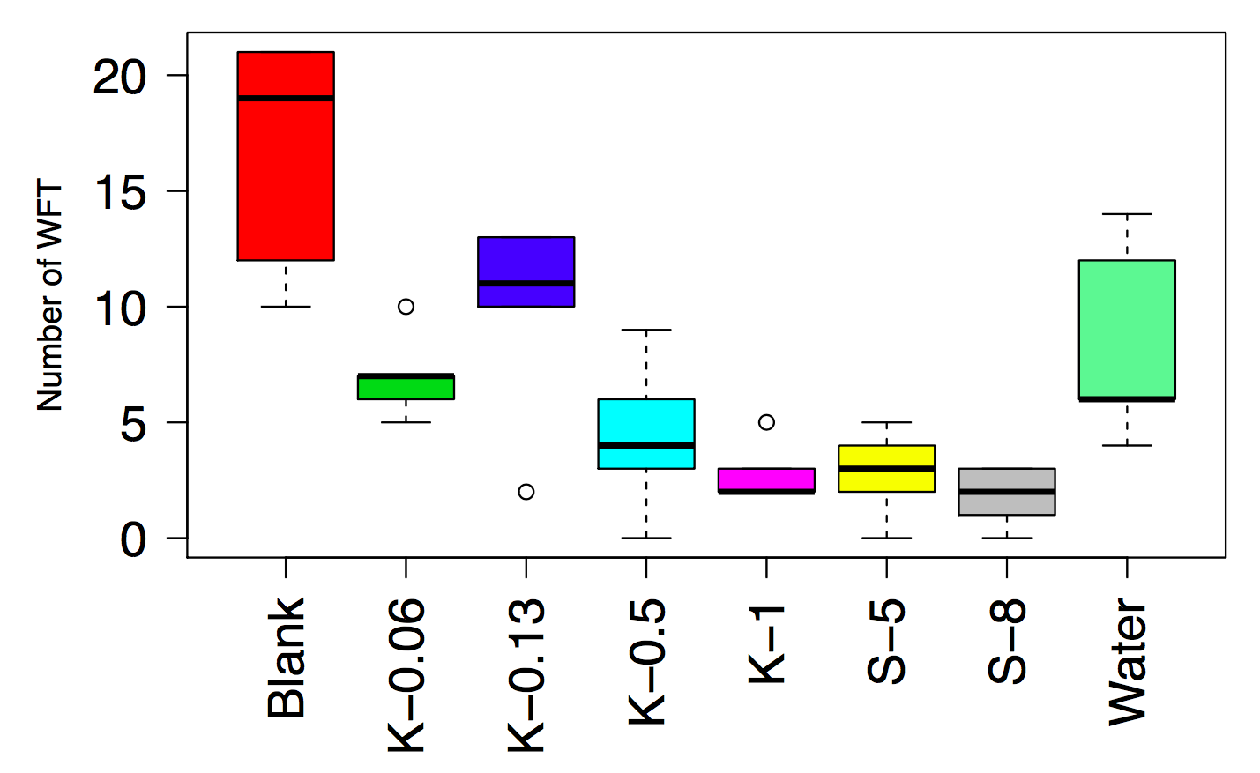

Figure 1: Boxplots showing the number of WFT obtained by the yellow sticky cards for each treatment

However, it should be noted that the water control had less than 10 WFT adults captured on the yellow sticky cards. Maybe it is because that the applications of solutions to the growing medium can move the pupae deeper into the growing medium profile, thus making it difficult for adults that were previously pupae to emerge from the growing medium. Therefore, caution must be exercised when interpreting the results of the experiment. However, some of the treatments may have affected the WFT pupae directly.

When I was analyzing the data, I fit the data into a simple linear model firstly. Because using the simple linear model is under a lot of assumptions, so after fitting the data into the linear model, I need to check all the assumptions about the simple linear model. First of all, I plotted the histogram about the model residuals frequency (Figure 2). From the histogram, I found it looks approximately normal. And then I tried Shapiro-Wilk normality test to check the normality, the p-value is equal to 0.5015. Then I can say I have 95% confidence that the residuals are normally distributed, which means the numbers of WFT adults captured by the yellow sticky cards are also normally distributed.

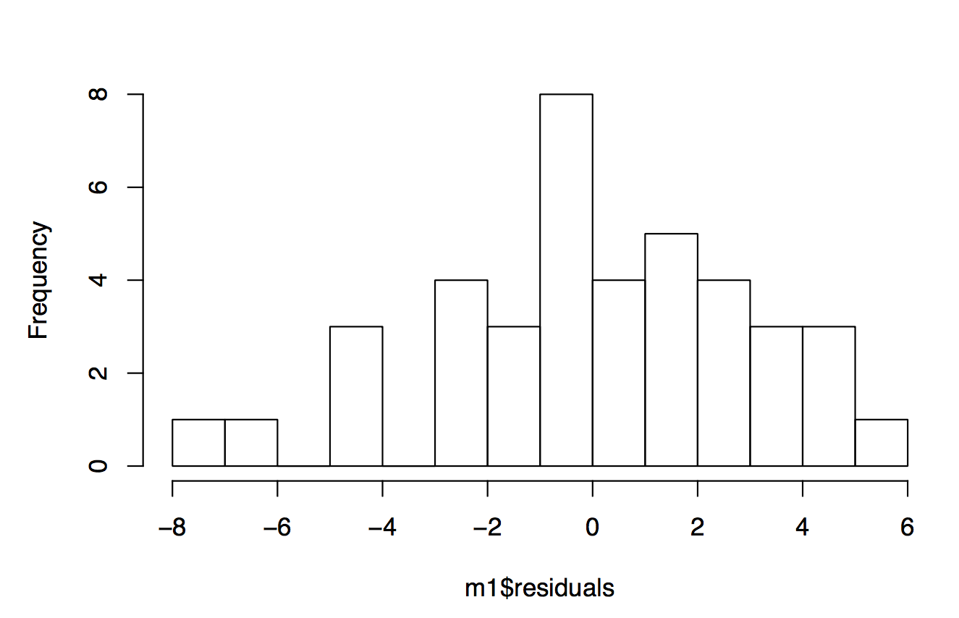

Figure 2: Histogram showing the residuals frequency from simple linear model

Secondly, I checked the assumption of constant variance. I found it is hard to find a perfect test to check that. What I did was plotting the relationship between the model residuals and the 8 treatments (Figure 3). From figure 3, I found the residuals have no obvious trend, they are approximately symmetric with respect to the horizontal zero line. Then I assumed that all the residuals have constant variance, which means the variance between all the treatments are the same.

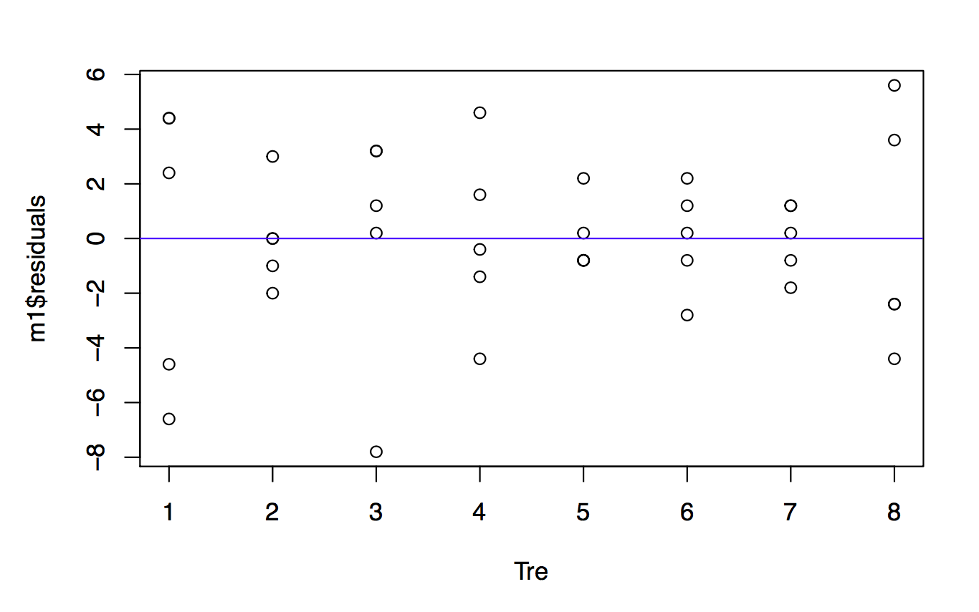

Figure 3: The linear model residuals for 8 different treatments

Because the linear model assumes all the dependent variables are independent and identically distributed random variables. So what I need to do for next step is checking the independence. I plotted the graph about the relationship between all the residuals(Figure 4). And it’s hard to say whether the residuals are correlated with each other. But when I used the correlation function in R, the result showed the correlation between the model residuals was -0.44. It seems there is correlation between them. While I tried Durbin-Watson test, I found the p-value equals 0.941, which means there is no correlation between them. Generally, all the numbers captured by the yellow sticky card are independent with each other.

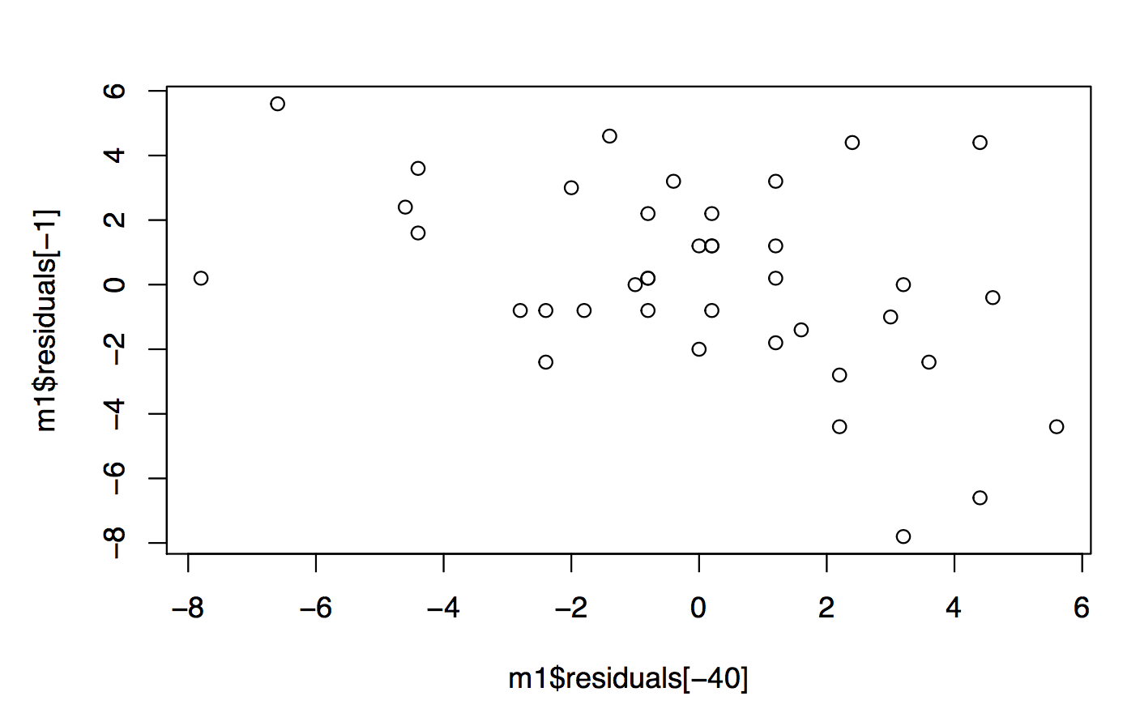

Figure 4: Relationship between all the model residuals

The next step is to check whether there are some outliers in the data. For this type of checking, I prefer using the graphic method. After I plotted the number of WFT captured by the yellow sticky cards for 8 different treatments (Figure 5). I found for treatment 3, the lowest value is only 2, which is much smaller than other values, which are all around 10 or more than 10. Then I will assume that value is an outlier. For other treatments, it is very hard to say there are some other outliers from figure 5. Even we found there is one outlier in the data, but it is not easy to deal with it. What I can do for the outlier is trying to find a better model which can explain the data well.

Until now, it seems all the assumptions can all be met. This is very good, because that

means it is likely to be reasonable to use the simple linear model to analyze the data.

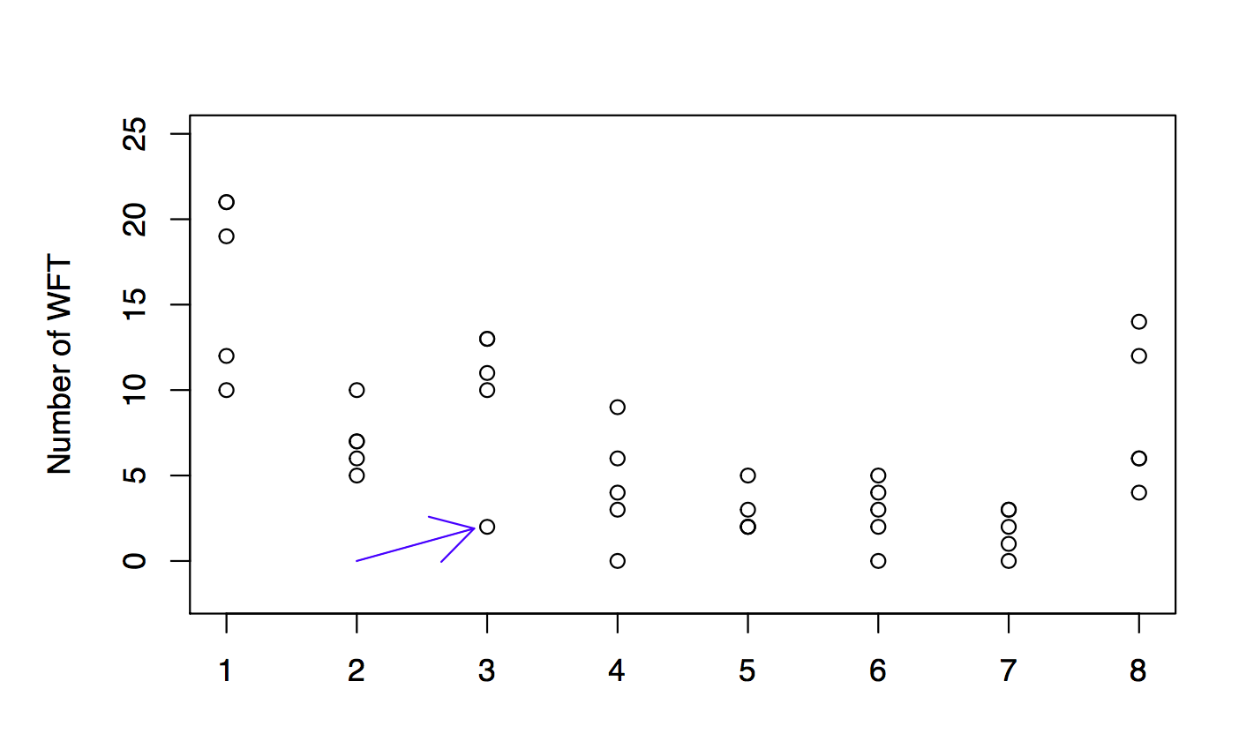

Figure 5: The number of WFT captured by the yellow sticky cards for 8 different treatments

However, we still need to check the linear structure. Because we all know that the data are actually binomial data. Then I fit the data into a generalized linear model. But the problem is after I check the AIC and BIC of the two models (Table 2), I find the AIC and BIC values of the generalized linear model are 228.37 and 241.88, which are higher than the simple linear model 218.82 and 234.02. After I use quasibinomial instead of binomial in the generalized linear model, I find the result shows that the dispersion parameter for quasibinomial family taken to be 2.889032, which means there is overdispersion in the binomial generalized linear model.

In order to solve the problem of overdispersion in the model. I think maybe the data follows a beta binomial data. Then I fit the data into a generalized linear model which assumes the data follows a beta binomial distribution. And I find that the AIC and BIC values are 207.19 and 222.39, which are much smaller than other models. For these data, I will say the best model should be generalized linear model which assumes the data follows a beta binomial distribution. But our goal for this experiment is comparing the differences between all the treatments. And it is hard to compare the differences with that generalized linear model. However, we can find that almost all the simple linear model assumptions can be met. For this project, I will still use the simple linear model.

|  |  |  |  |
| --- | --- | --- | --- |
| Models | Degree of freedom | AIC | BIC |
| Simple  Linear model | 9 | 218.82 | 234.02 |
| Binomial | 8 | 228.37 | 241.88 |
| Quasibinomial | 8 | NA | NA |
| Beta Binomial | 9 | 207.19 | 222.39 |

Table 2: AIC and BIC values for different models

For comparing the differences between all the treatment groups. I use Tukey test in R, and get the results below (Table 3). We can find that there is no difference between Blank and KleenGrow™ at the concentrations of 0.13 fl oz/1 gallon, but there are some differences between KleenGrow™ at the concentrations of 0.13 fl oz/1 gallon and KleenGrow™ at the concentrations of 1.0 fl oz/1 gallon.

|  |  |  |
| --- | --- | --- |
|  | WFT | Groups |
| Blank | 16.6 | a |
| K-0.13 | 9.8 | ab |
| Water | 8.4 | bc |
| K-0.06 | 7.0 | bc |
| K-0.5 | 4.4 | bc |
| K-1 | 2.8 | c |
| S-5 | 2.8 | c |
| S-8 | 1.8 | c |

Table 3: Tukey test results for the simple linear model

As a whole, in terms of the result of Tukey test, I will say the treatments of water, KleenGrow™ at the concentrations of 0.06 fl oz/1 gallon, KleenGrow™ at the concentrations of 0.5 fl oz/1 gallon, KleenGrow™ at the concentrations of 1.0 fl oz/1 gallon, STRIP-IT PRO™ at the concentrations of 8.0 fl oz/1 gallon and 5.0 fl

oz/1 gallon all have efficacy on the pupae stage of the western flower thrips. But the efficacy differences between them are not significant.

There are also some additional research still needs to be done. First of all, I need to fit the data into beta-binomial distribution model and check all the assumptions. Because I found the AIC and BIC values are the lowest than others’ (Table 2), which means this model should be the best model for dealing with the data about the number of WFT captured by the yellow sticky cards. Secondly, I will try to remove the outlier from the data and check whether it will have some effects on the result. I know it is not a good choice to remove the outlier because our data are not big. But maybe it can make the model be more accurate. At last, I will also compute the AIC and BIC values for quasibinomial model by hand, and check whether the values are lower than other models. My goal is finding the best model which can fit the data very well and also comparing the differences between all the treatments.

**Reference:**

1. Richards, O.W. and Davies, R.G. (1978) Imms’ Outlines of Entomology, London: Chapman and Hall.
2. Brødsgaard, H.F. (1989) *Frankliniella occidentalis*(Thysanoptera: Thripidae)-a new pest in Danish glasshouses. A review. Tidsskrift for Planteavl 93, 83–91.
3. Tommasini, M.G. and Maini, S. (1995*) Frankliniella occidentalis*and other thrips harmful to vegetable and ornamental crops in Europe. In A.J.M. Loomans, J.C. van Lenteren, M.G. Tommasini, S. Maini and J. Riudavets (eds) Biological control of thrips pests, pp. 1–42. Wageningen: Wageningen Agricultural University Papers.
4. Heming, B.S. (1995) History of the germ line in male and female thrips. In B.L. Parker, M. Skinner and T. Lewis (eds) Thrips biology and management, pp. 505–35. New York: Plenum Press.
5. Moritz, G. (1997) Stucture, growth and development. In T. Lewis(ed) Thrips as crop pests, pp. 15–63. Wallingford, UK: CAB International.
6. Lacasa A and Llorens JM, Trips y su Control Biológico (I). Pisa Ediciones, Alicante, Spain (1996).
7. 3 Lewis T, Chemical control, in Thrips as Crop Pests, ed. by LewisT. CAB International, New York, NY, pp. 567–594(1998).
8. Immaraju JA, Paine TD, Bethke JA, Roob KL and Newman JP, WFT (Thysanoptera: Thripidae) resistance to insecticides in coastal California greenhouses. J Econ Entomol 85: 9–14 (1992).